**1. The CRR binomial option pricing model for European options runs in O(n) time using Combinatorial method**

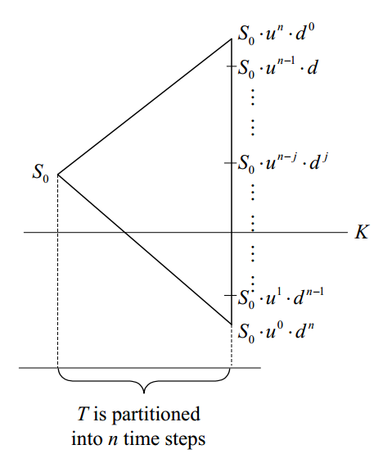

European option value $=e^{-rT}\sum_{j=0}^{n}{\left(\left({n \atop j}\right)p^{n-j}{(1-p)}^{j}\max\left({z(S}_{0}u^{n-j}d^{j}-X\right),0\right)}$, where $\left({n \atop j}\right)$, also denoted as $C_{j}^{n}$, is combination of *j* from *n*, $u=e^{σ\sqrt{∆t}}$, $d=e^{-σ\sqrt{∆t}}$, $p=\frac{e^{r∆t}-d}{u-d}$, z = 1 for call option and z = -1 for put option.

$\left({n \atop j}\right)$ can be pre-calculated in O(n) time.

**2. N(d)**

$$\int_{-∞}^{d}{f\left(x\right)dx=\int_{0}^{1}{f(d-\frac{1-t}{t})\frac{dt}{t^{2}}} }$$

$$N(d)=\int_{-∞}^{d}{\frac{1}{\sqrt{2π}}e^{-\frac{1}{2}x^{2}}dx=\int_{0}^{1}{\frac{1}{\sqrt{2π}}e^{-\frac{1}{2}{(d-\frac{1-t}{t})}^{2}}\frac{dt}{t^{2}}} }$$

**3. Error Function: Numerical approximation**

Over the complete range of values, there is an approximation with a maximal error of $1.2∙{10}^{-7}$, as follows:

$$erf⁡(x)=\left\{\begin{aligned}1-τ, for x ≥0 \\ τ-1, for x<0\end{aligned}\right.$$

with $τ=t∙exp⁡(-x^{2}-1.26551223+1.00002368∙t+0.37409196∙t^{2}+0.09678418∙t^{3}-0.18628806∙t^{4}+0.27886807∙t^{5}-1.13520398∙t^{6}+1.18851587∙t^{7}-0.82215223∙t^{8}+0.17087277∙t^{9})$

or $τ=t∙exp⁡(-x^{2}-1.26551223+t∙\left(1.00002368+t∙\left(0.37409196+t∙\left(0.09678418+t∙\left(-0.18628806+t∙\left(0.27886807+t∙\left(-1.13520398+t∙\left(1.18851587+t∙\left(-0.82215223+t∙0.17087277\right)\right)\right)\right)\right)\right)\right)\right))$

and $t=\frac{1}{1+0.5\left|x\right|}$

**4. Correlation**

$$erf(x)=\int_{0}^{x}{\frac{2}{\sqrt{π}}e^{-t^{2}}dt }$$

$$N(d)=\int_{-∞}^{d}{\frac{1}{\sqrt{2π}}e^{-\frac{1}{2}x^{2}}dx=\frac{1}{2} (1+}erf(\frac{d}{\sqrt{2}}))$$